COSC 4377 – Networking - Kevin B Long

# interlocking-uh-m-186.eps

# **Homework #3**

Due 11:59pm, Sunday, 18 February, 2018

100 points total

Multiple submissions accepted.

____________________________Joshua Nguyen____________________________

Name

______________1304578_____________

PeopleSoft ID

1. (51 pts) Complete the second socket lab:  **Socket Programming Assignment 2: UDP**

Look in the Google Drive folder, under “[Socket Programming Assignments](https://drive.google.com/open?id=10HV8S3WtNK_q346cPxOFdZdHapcMOV4K)” for the file “[Socket2_UDPpinger](https://drive.google.com/open?id=10HV8S3WtNK_q346cPxOFdZdHapcMOV4K).” It has instructions on what to turn in.

There is a new tutorial on Blackboard on the initial page written by our TA’s on how to install the PyScript interpreter in Windows which reqires installing Python and then PyScript. However, everything is available for the Mac and for Linux.

Start by going to the installation page for all platforms: <https://www.python.org/downloads/> and choose the 2.7.14 release. Then install JetBrains at <https://www.jetbrains.com/pycharm/download/>. More information is available in the document posted on the initial page in BlackBoard.

If you wish to install Windows on your Mac (and why not, it’s free), you’ll need two things: a virtual machine program that will host the Windows OS, and then Windows. For the former, there are three popular choices: VMware Fusion ($100), Parallels ($40-ish with a student ID from educational sellers), and VirtualBox (<https://www.virtualbox.org>), free.

If you need the Windows software to install on top of the virtual machine (or for installing on a Windows machine), you can take advantage of UH's participation in [Microsoft's Imagine program](https://e5.onthehub.com/WebStore/ProductsByMajorVersionList.aspx?ws=259c59cc-ae09-e211-bd05-f04da23e67f6&amp;vsro=8).  Read more about that in "[Downloading Windows 10.pdf](https://drive.google.com/open?id=1ZivscEYrWognSE0IIZIsBKJlIhMQ39ql)" in the Extras folder on our Google Drive.

Include your code with your homework as a file that the TA’s can download and run. You will need to create a ZIP archive as BlackBoard will only allow you to upload a single file. Alternatively, since unlimited submissions are allowed, you can upload your homework first, and then the Python code.

1. (7x7 pts) Choose your favorite browser. Pick a commercial site that you don’t visit and don’t care if you have to log in again. Clear the cookies for just that site from your cache. You may have to search the help pages!

In google, here’s what I used: <https://support.google.com/chrome/answer/95647?hl=en-419>

In Firefox, I navigated to this site by entering it in the URL field:

about:preferences#privacy

1. So what’s the site you’re planning to visit? ___**_www.newegg.com__**______________

Find and clear any cookies that have the name of the site. Leave the cookie manager open.

I chose [www.jcpenney.com](http://www.jcpenney.com). You should pick another site.

1. Go to the site’s home page. Consult the cookie manager. Were cookies created by opening their home page? ___**yes_**__ How many? __**_4_**_ Include a snapshot of what the cookie manager shows. For example, here’s what Chrome showed me:

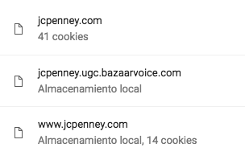

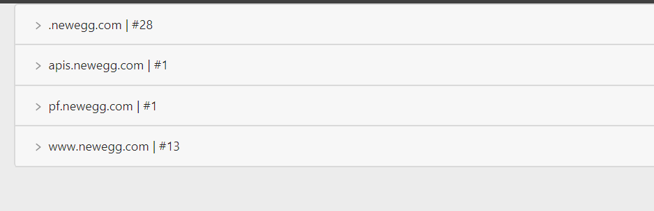

1. Click on a product on the web page. Observe the URL in your browser after you have clicked on the product. Paste it here.

<https://www.jcpenney.com/p/arizona-long-sleeve-thermal-top/ppr5007324806?pTmplType=regular&rrec=true&rrplacementtype=norecs>

[**https://www.newegg.com/Product/Product.aspx?Item=N82E16824009969&utm_medium=Email&utm_source=IGNEFL022018C&cm_mmc=EMC-IGNEFL022018C-_-EMC-022018-Latest-Index-_-LCDLEDMonitors-_-24009969-S0A&ignorebbr=1**](https://www.newegg.com/Product/Product.aspx?Item=N82E16824009969&utm_medium=Email&utm_source=IGNEFL022018C&cm_mmc=EMC-IGNEFL022018C-_-EMC-022018-Latest-Index-_-LCDLEDMonitors-_-24009969-S0A&ignorebbr=1)

Do you see a pattern of variables and values encoded in the URL? For example, separated by ampersand symbols (&’s)? **Yes, 022018 is repeated again across the url link!**

1. Examine one of the cookies. If navigating did not produce a cookie, check your settings, try another browser, or another site. Choose a cookie that looks like it has something that identifies you – a session ID, or a guest ID, that sort of thing, instead of the type of system or your apparent country or language. Inspect the cookie, and paste a snapshot of the details your browser provides. .

Here was the one I chose:

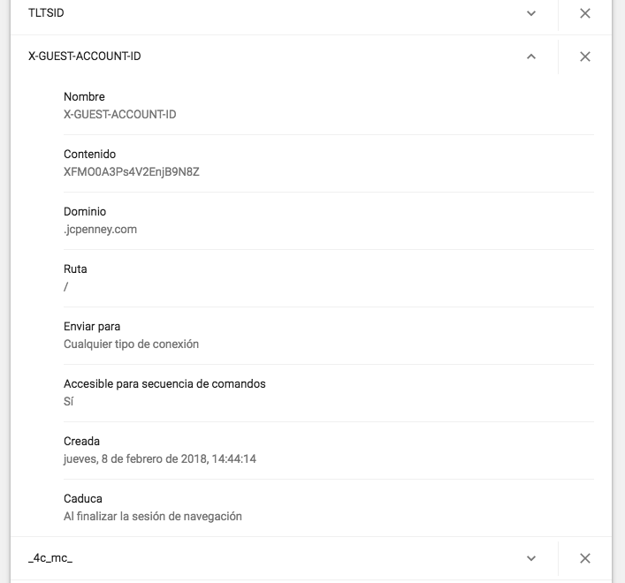

Although most of the fields were readable and had a variable-value combination, the guest account ID looks encrypted or at the least very random: XFM00A3Ps4V2EnjB9N8Z.

What about yours?

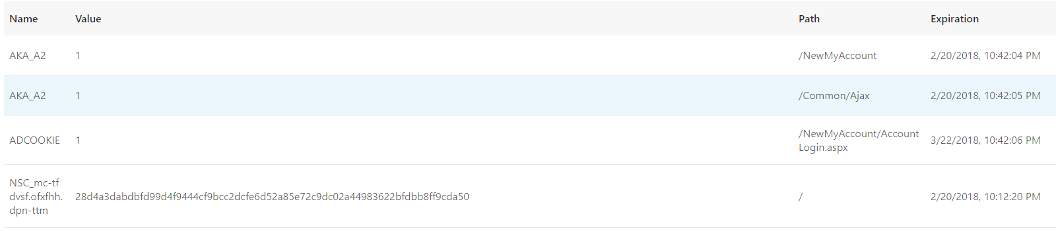

1. Add the item to your cart, and then clear the cookies for the domain. Now refresh the page. Is the item still in the cart? **__no____**
2. Examine the cookies again. Look for the same cookie from (d). Was it replaced? Does it still have the same unique identifier as before? Mine was not:

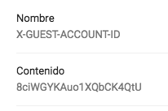

**No, it was not replaced. It was otherwise added with more cookies instead**

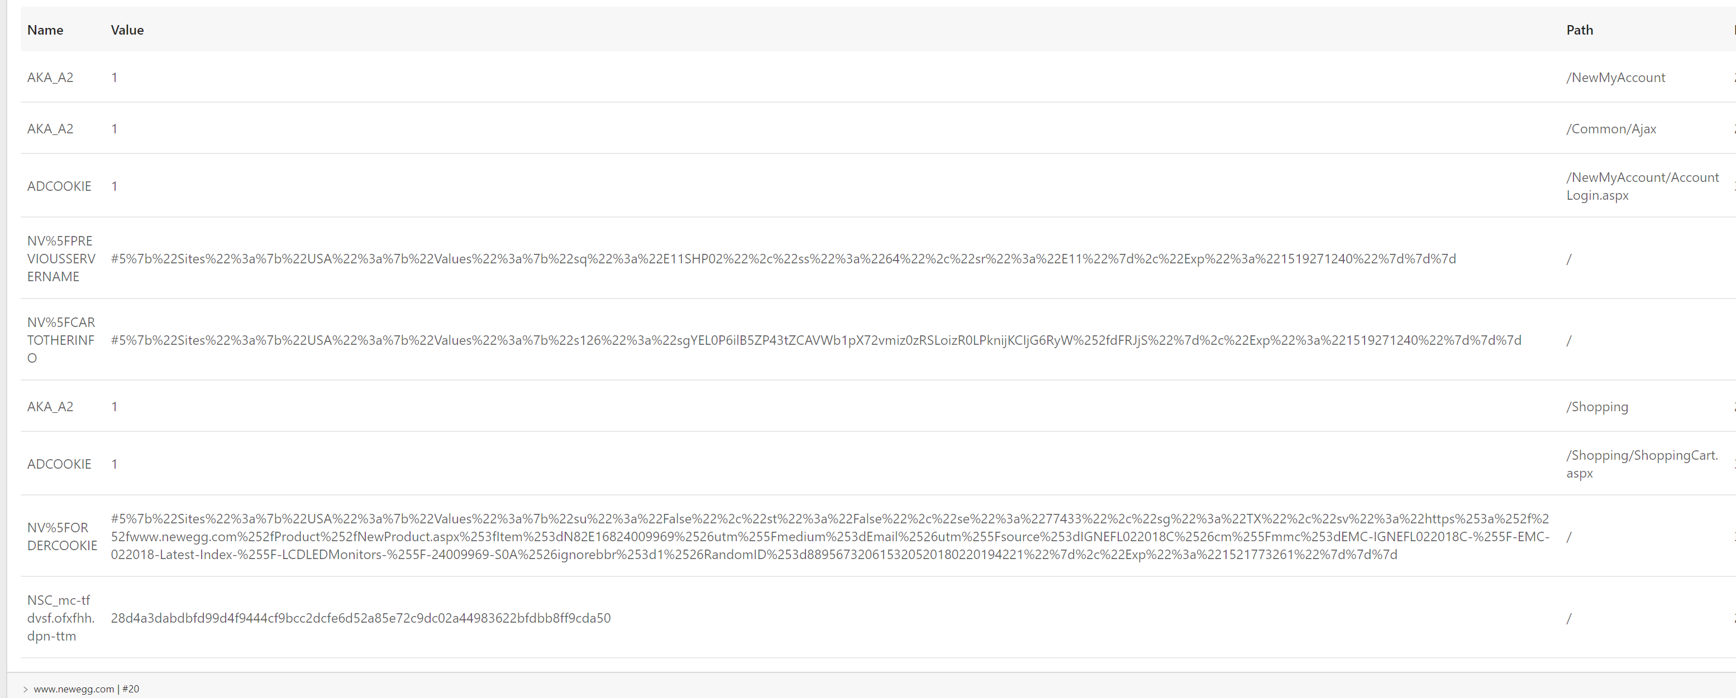

1. Wait a few minutes and go to a site with google ads. Did you see your cart item? I happened to need to go to aboutus.com/Gvt3.com and look what ads I got! Lol. My browser might not remember what I put in my cart, but Google did!

**Yes, I see my cart item in the google ads in my browser!**

